100 Days of Code: The Complete Python Pro Bootcamp for 2022

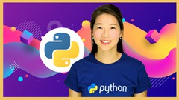

**410. Step 1 - Use BeautifulSoup to Scrape the Product Price**

Open

Course content

Overview

Q&AQuestions and answers

Notes

Announcements

Reviews

Learning tools

Master Python by building 100 projects in 100 days. Learn data science, automation, build websites, games and apps!

Rating: 4.7 out of 1**4.7**

137,560 ratings

**610,253**

Students

**64 hours**

Total

Last updated December 2021

English

English, Arabic [Auto], 15 more

**What you'll learn**

* You will master the Python programming language by building 100 unique projects over 100 days.
* You will learn automation, game, app and web development, data science and machine learning all using Python.
* You will be able to program in Python professionally
* You will learn Selenium, Beautiful Soup, Request, Flask, Pandas, NumPy, Scikit Learn, Plotly, and Matplotlib.
* Create a portfolio of 100 Python projects to apply for developer jobs
* Be able to build fully fledged websites and web apps with Python
* Be able to use Python for data science and machine learning
* Build games like Blackjack, Pong and Snake using Python
* Build GUIs and Desktop applications with Python

**Description**

Welcome to the 100 Days of Code - The Complete Python Pro Bootcamp,**the only course you need** to learn to code with Python. With over 500,000 **5 STAR reviews** and a 4.8 average, my courses are some of the HIGHEST RATED courses in the history of Udemy!

**100 days, 1 hour per day, learn to build 1 project per day, this is how you master Python.**

At 60+ hours, this Python course is without a doubt the **most comprehensive**Python course available anywhere online. Even if you have **zero** programming experience, this course will take you from **beginner to professional**. Here's why:

* The course is taught by the **lead instructor** at the App Brewery, London's **best in-person programming Bootcamp**.
* The course has been updated to be **2022 ready**and you'll be learning the latest tools and technologies used at large companies such as Apple, Google and Netflix.
* This course doesn't cut any corners, there are beautiful **animated explanation videos** and tens of **real-world projects** which you will get to build. e.g. Tinder auto swiper, Snake game, Blog Website, LinkedIn Auto Submit Job Application
* The curriculum was developed over a period of**2 years**, with comprehensive student testing and feedback.
* We've taught over 600,000 students how to code and many have gone on to **change their lives**by becoming professional developers or starting their own tech startup.
* You'll save yourself **over $12,000**by enrolling, and still get access to the same teaching materials and learn from the same instructor and curriculum as our in-person programming Bootcamp.
* The course is **constantly updated** with new content, with new projects and modules determined by students - that's you!

We'll take you **step-by-step** through engaging video tutorials and teach you everything you need to know to succeed as a Python developer.

The course includes over **60 hours** of HD video tutorials and builds your programming knowledge while making real-world Python projects.

Throughout this comprehensive course, we cover a massive amount of tools and technologies, including:

* Python 3 - the latest version of Python
* PyCharm, Jupyter Notebook, Google Colab
* Python Scripting and Automation
* Python Game Development
* Web Scraping
* Beautiful Soup
* **Selenium** Web Driver
* Request
* WTForms
* Data Science
* Pandas
* **NumPy**
* Matplotlib
* **Plotly**
* Scikit learn
* Seaborn
* Turtle
* Python GUI Desktop App Development
* **Tkinter**
* Front-End Web Development
* HTML 5
* CSS 3
* Bootstrap 4
* Bash Command Line
* Git, **GitHub** and Version Control
* Backend Web Development
* **Flask**
* REST
* **APIs**
* Databases
* SQL
* **SQLite**
* PostgreSQL
* Authentication
* Web Design
* Deployment with GitHub Pages, Heroku and GUnicorn
* and much much more!

By the end of this course, you will be **fluently** programming in Python and you'll be so good at Python that you can get a job or use the language professionally.

You'll also build a **portfolio** of **100 projects** that you can show off to any potential employer. Including:

* Blackjack
* Snake Game
* Pong Game
* Auto Swipe on Tinder
* Auto Job Applications on LinkedIn
* Automate Birthday Emails/SMS
* Fully Fledged Blog Website
* Build Your Own Public API
* Data Science with Google Trends
* Analysing Lego Datasets
* Google App Store Analysis
* and much much more!

**Sign up today, and look forward to:**

* Video Lectures
* Code Challenges and Exercises
* Fully Fledged Projects
* Quizzes
* Programming Resources and Cheatsheets
* Downloads
* Our best selling 12 Rules to Learn to Code eBook
* $12,000+ Python Pro Bootcamp course materials and curriculum

Don't just take my word for it, check out what existing students have to say about my courses:

"Angela is just incredible, awesome and just fantastic in this course. I've never had such an instructor; **detailed** in every aspect of the course, gives precise explanations, gives you the anxiety to learn etc. She's got that ability to make fun while explaining things for better understanding. I really love this course." - Ekeu MonkamUlrich

"Angela is very thorough without ever being boring. I've taken MANY online courses in my life including my Bachelors and Masters degrees. She is by far the best instructor I've ever had. This course is **packed with thousands of dollars worth of great instruction**, and paced well enough for anyone to pick coding up and run with it- Thank you!" - J Carlucci

"Love the way Angela explains things. Easy to follow and full of logic. I can say she must spend a lot of energy creating this great course. Thank you and I recommend it to all who's interested in coding!" - Yiqing Zheng

"So far (on my third day) this course has taught me **more than I was able to learn in multiple other programming courses**. This course is clearly outlined and builds upon itself gradually in an easy to understand way." - Normal Ramsey

"It's a different approach to teaching Web Development. I like that you are **given everything possible to succeed** from the onset." - Ronick Thomas

The tutor is simply AMAZING, by far the best tutor I have ever had. I would give her 10 stars out of 5. She is not just punching the code and talking to herself, but she is actually explaining things. She keeps on giving really useful hints and she will give you a great load of other references. I always knew what I was doing and why I was doing it. All the extra challenges have just made me remember and understand things better. - Peter Dlugos

**REMEMBER… I'm so confident that you'll love this course that we're offering a FULL money-back guarantee for 30 days! So it's a complete no-brainer, sign up today with ZERO risk and EVERYTHING to gain.**

So what are you waiting for? Click the buy now button and join the world's highest-rated development course.

**Who this course is for:**

* If you want to learn to code from scratch through building fun and useful projects, then take this course.
* If you want to start your own startup by building your own websites and web apps.
* If you are a complete beginner then this course will be everything you need to become a Python professional
* If you are a seasoned programmer wanting to switch to Python then this is the quickest way. Learn through coding projects.
* If you are an intermediate Python programmer then you know 100 days of code challenges will help you level up.

Show more

**Instructor**

[**Dr. Angela Yu**](https://deloittedevelopment.udemy.com/user/4b4368a3-b5c8-4529-aa65-2056ec31f37e/)

Developer and Lead Instructor

I'm Angela, I'm a developer with a passion for teaching. I'm the **lead instructor** at the London App Brewery, London's leading **Programming Bootcamp**. I've helped hundreds of thousands of students learn to code and change their lives by becoming a developer. I've been invited by companies such as Twitter, Facebook and Google to teach their employees.

My first foray into programming was when I was just 12 years old, wanting to build my own Space Invader game. Since then, I've made **hundred of websites, apps and games**. But most importantly, I realised that my **greatest passion** is teaching.

I spend most of my time researching how to make **learning to code fun** and make **hard concepts easy to understand**. I apply everything I discover into my bootcamp courses. In my courses, you'll find lots of geeky humour but also lots of **explanations and animations** to make sure everything is easy to understand.

**I'll be there for you every step of the way.**

Show more

**Featured review**

**David K.**

39 courses

29 reviews

Rating: 5.0 out of 5a year ago

Angela is a great teacher and I have taken some other courses of hers. This one seems to be of the same great quality. If you want a simple code-along, this is not for you. Angela will Challenge you to actually use what she teaches you many times along the way. You WILL know how to program Python when you finish this course!

Show more

Was this review helpful?

See all reviews (137,560)

**Requirements**

* No programming experience needed - I'll teach you everything you need to know
* A Mac or PC computer with access to the internet
* No paid software required - I'll teach you how to use PyCharm, Jupyter Notebooks and Google Colab
* I'll walk you through, step-by-step how to get all the software installed and set up

English

* [Get the app](https://deloittedevelopment.udemy.com/mobile/)
* [About us](https://about.udemy.com/?locale=en-us)
* [Help and Support](https://deloittedevelopment.udemy.com/support/)
* [Terms](https://deloittedevelopment.udemy.com/terms/ub/)
* [Privacy policy](https://deloittedevelopment.udemy.com/terms/ub-privacy/)
* [Sitemap](https://deloittedevelopment.udemy.com/sitemap/)
* [Accessibility statement](https://about.udemy.com/accessibility-statement?locale=en-us)

© 2022 Udemy, Inc.

410. Step 1 - Use BeautifulSoup to Scrape the Product Price

**Step 1 - Use BeautifulSoup to Scrape the Product Price**

1. Find a product on Amazon that you want to track and get the product URL or just use the one I'm tracking.

<https://www.amazon.com/Instant-Pot-Duo-Evo-Plus/dp/B07W55DDFB/ref=sr_1_1?qid=1597662463>

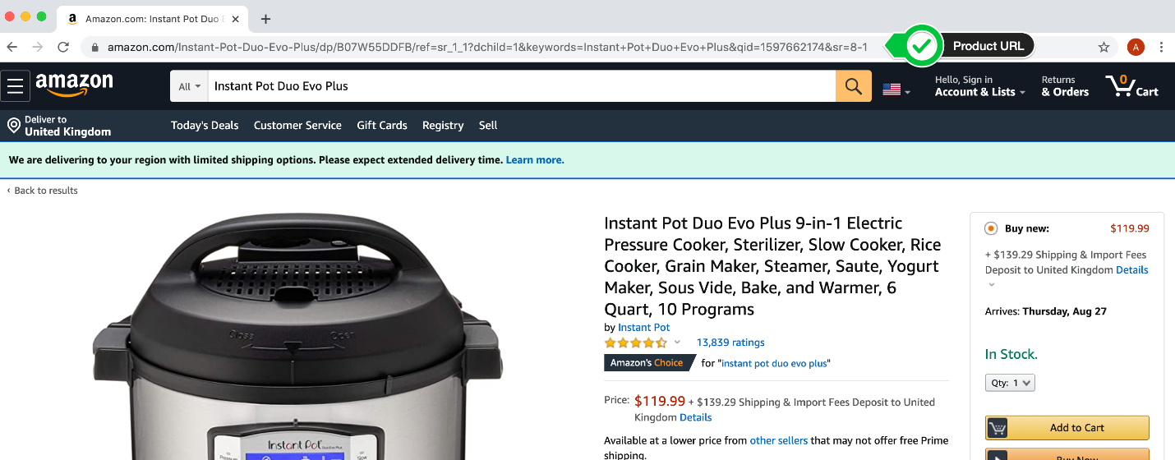

In addition to the URL, when you browser tries to load up a page in Amazon, it also passes a bunch of other information. e.g. Which browser you're using, which computer you have etc.

These additional pieces of information is passed along in the request Headers.

You can see your browser headers by going to this website:

<http://myhttpheader.com/>

2. Use the requests library to request the HTML page of the Amazon product using the URL you got from 1.

HINT 1: You'll need to pass along some headers in order for the request to return the actual website HTML. At minimum you'll need to give your "User-Agent" and "Accept-Language" values in the request header.

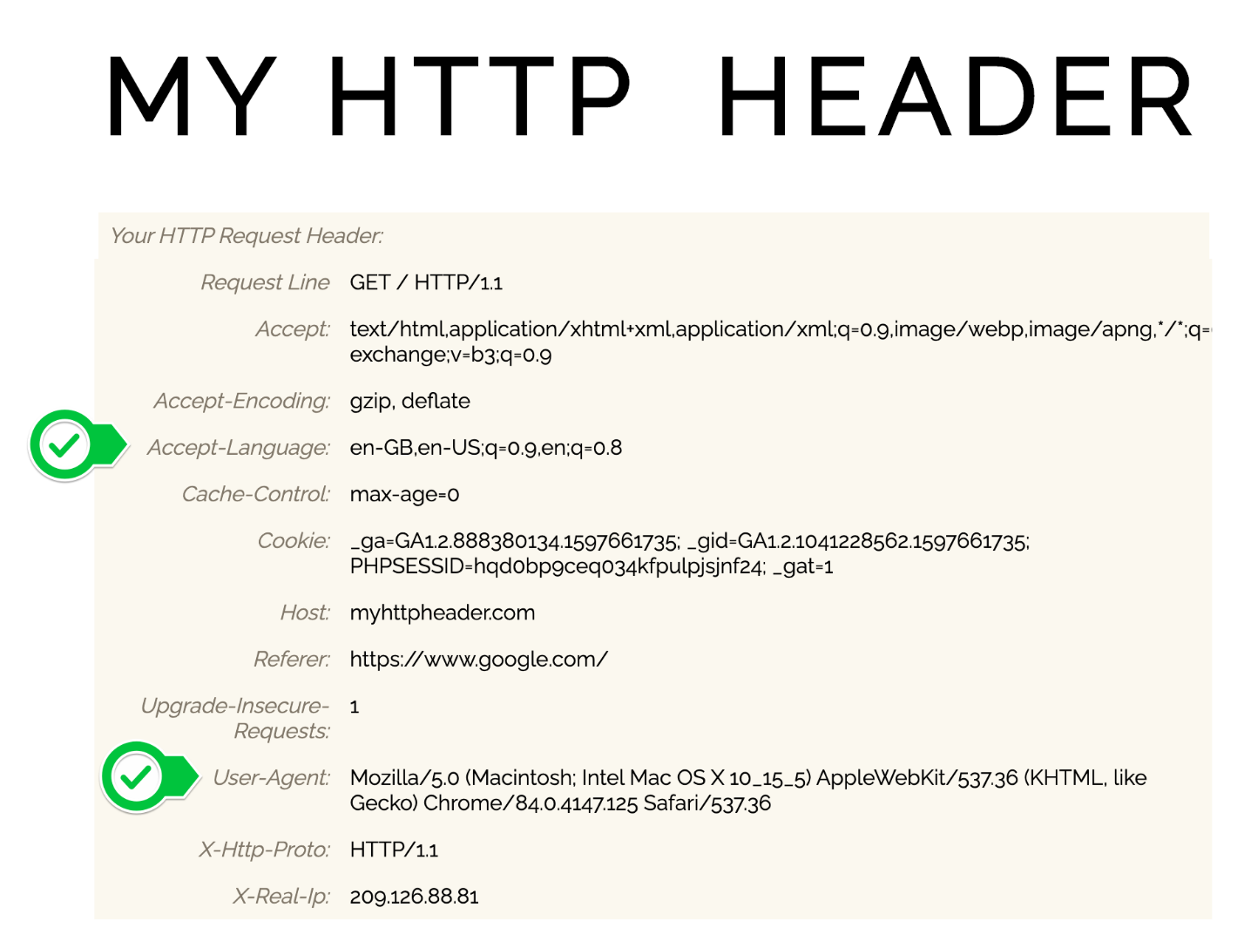

HINT 2: Remember this is how you pass headers with the requests library:

<https://stackoverflow.com/questions/6260457/using-headers-with-the-python-requests-librarys-get-method>

HINT 3: Print the output of the get request and make sure the actual HTML of the web page is printed, if not try adding more items from your header from hint1. Sometimes, Amazon might just return the Captcha page.



3. Use BeautifulSoup to make soup with the web page HTML you get back. You'll need to use the "**lxml**" parser instead of the "html.parser" for this to work.

HINT: If you get an error that says "**bs4.FeatureNotFound: Couldn't find a tree builder with the features you requested: html-parser.**" Then it means you're not using the right parser, you'll need to import lxml at the top and install the module then use "lxml" instead of "html.parser" when you make soup.

4. Use BeautifulSoup to get hold of the price of the item as a floating point number and print it out.

HINT: You might need to use the split() method: <https://www.w3schools.com/python/ref_string_split.asp>

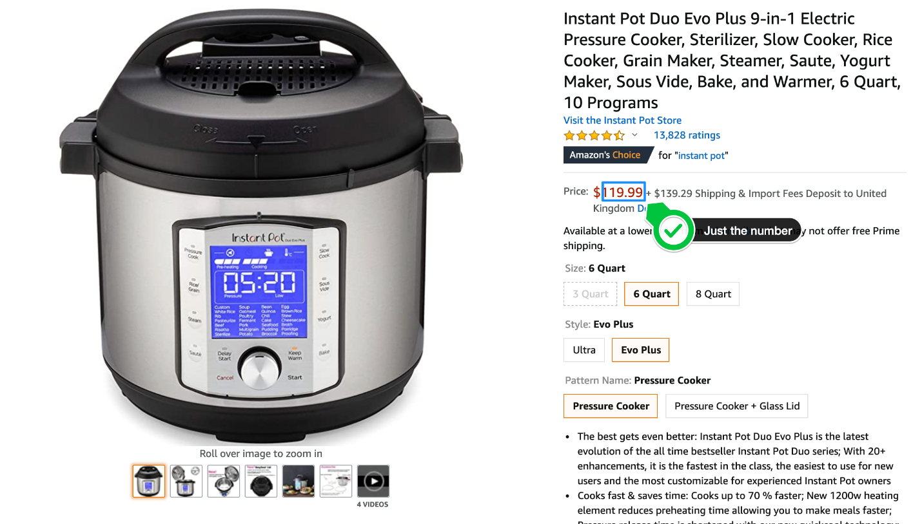

[SOLUTION](https://gist.github.com/angelabauer/6b2d01cf2c265910ea8c03003244939f)

100 Days of Code: The Complete Python Pro Bootcamp for 2022



**411. Step 2 - Email Alert When Price Below Preset Value**

Open

Course content

Overview

Q&AQuestions and answers

Notes

Announcements

Reviews

Learning tools

Master Python by building 100 projects in 100 days. Learn data science, automation, build websites, games and apps!

Rating: 4.7 out of 1**4.7**

137,560 ratings

**610,253**

Students

**64 hours**

Total

Last updated December 2021

English

English, Arabic [Auto], 15 more

**What you'll learn**

* You will master the Python programming language by building 100 unique projects over 100 days.
* You will learn automation, game, app and web development, data science and machine learning all using Python.
* You will be able to program in Python professionally
* You will learn Selenium, Beautiful Soup, Request, Flask, Pandas, NumPy, Scikit Learn, Plotly, and Matplotlib.
* Create a portfolio of 100 Python projects to apply for developer jobs
* Be able to build fully fledged websites and web apps with Python
* Be able to use Python for data science and machine learning
* Build games like Blackjack, Pong and Snake using Python
* Build GUIs and Desktop applications with Python

**Description**

Welcome to the 100 Days of Code - The Complete Python Pro Bootcamp,**the only course you need** to learn to code with Python. With over 500,000 **5 STAR reviews** and a 4.8 average, my courses are some of the HIGHEST RATED courses in the history of Udemy!

**100 days, 1 hour per day, learn to build 1 project per day, this is how you master Python.**

At 60+ hours, this Python course is without a doubt the **most comprehensive**Python course available anywhere online. Even if you have **zero** programming experience, this course will take you from **beginner to professional**. Here's why:

* The course is taught by the **lead instructor** at the App Brewery, London's **best in-person programming Bootcamp**.
* The course has been updated to be **2022 ready**and you'll be learning the latest tools and technologies used at large companies such as Apple, Google and Netflix.
* This course doesn't cut any corners, there are beautiful **animated explanation videos** and tens of **real-world projects** which you will get to build. e.g. Tinder auto swiper, Snake game, Blog Website, LinkedIn Auto Submit Job Application
* The curriculum was developed over a period of**2 years**, with comprehensive student testing and feedback.
* We've taught over 600,000 students how to code and many have gone on to **change their lives**by becoming professional developers or starting their own tech startup.
* You'll save yourself **over $12,000**by enrolling, and still get access to the same teaching materials and learn from the same instructor and curriculum as our in-person programming Bootcamp.
* The course is **constantly updated** with new content, with new projects and modules determined by students - that's you!

We'll take you **step-by-step** through engaging video tutorials and teach you everything you need to know to succeed as a Python developer.

The course includes over **60 hours** of HD video tutorials and builds your programming knowledge while making real-world Python projects.

Throughout this comprehensive course, we cover a massive amount of tools and technologies, including:

* Python 3 - the latest version of Python
* PyCharm, Jupyter Notebook, Google Colab
* Python Scripting and Automation
* Python Game Development
* Web Scraping
* Beautiful Soup
* **Selenium** Web Driver
* Request
* WTForms
* Data Science
* Pandas
* **NumPy**
* Matplotlib
* **Plotly**
* Scikit learn
* Seaborn
* Turtle
* Python GUI Desktop App Development
* **Tkinter**
* Front-End Web Development
* HTML 5
* CSS 3
* Bootstrap 4
* Bash Command Line
* Git, **GitHub** and Version Control
* Backend Web Development
* **Flask**
* REST
* **APIs**
* Databases
* SQL
* **SQLite**
* PostgreSQL
* Authentication
* Web Design
* Deployment with GitHub Pages, Heroku and GUnicorn
* and much much more!

By the end of this course, you will be **fluently** programming in Python and you'll be so good at Python that you can get a job or use the language professionally.

You'll also build a **portfolio** of **100 projects** that you can show off to any potential employer. Including:

* Blackjack
* Snake Game
* Pong Game
* Auto Swipe on Tinder
* Auto Job Applications on LinkedIn
* Automate Birthday Emails/SMS
* Fully Fledged Blog Website
* Build Your Own Public API
* Data Science with Google Trends
* Analysing Lego Datasets
* Google App Store Analysis
* and much much more!

**Sign up today, and look forward to:**

* Video Lectures
* Code Challenges and Exercises
* Fully Fledged Projects
* Quizzes
* Programming Resources and Cheatsheets
* Downloads
* Our best selling 12 Rules to Learn to Code eBook
* $12,000+ Python Pro Bootcamp course materials and curriculum

Don't just take my word for it, check out what existing students have to say about my courses:

"Angela is just incredible, awesome and just fantastic in this course. I've never had such an instructor; **detailed** in every aspect of the course, gives precise explanations, gives you the anxiety to learn etc. She's got that ability to make fun while explaining things for better understanding. I really love this course." - Ekeu MonkamUlrich

"Angela is very thorough without ever being boring. I've taken MANY online courses in my life including my Bachelors and Masters degrees. She is by far the best instructor I've ever had. This course is **packed with thousands of dollars worth of great instruction**, and paced well enough for anyone to pick coding up and run with it- Thank you!" - J Carlucci

"Love the way Angela explains things. Easy to follow and full of logic. I can say she must spend a lot of energy creating this great course. Thank you and I recommend it to all who's interested in coding!" - Yiqing Zheng

"So far (on my third day) this course has taught me **more than I was able to learn in multiple other programming courses**. This course is clearly outlined and builds upon itself gradually in an easy to understand way." - Normal Ramsey

"It's a different approach to teaching Web Development. I like that you are **given everything possible to succeed** from the onset." - Ronick Thomas

The tutor is simply AMAZING, by far the best tutor I have ever had. I would give her 10 stars out of 5. She is not just punching the code and talking to herself, but she is actually explaining things. She keeps on giving really useful hints and she will give you a great load of other references. I always knew what I was doing and why I was doing it. All the extra challenges have just made me remember and understand things better. - Peter Dlugos

**REMEMBER… I'm so confident that you'll love this course that we're offering a FULL money-back guarantee for 30 days! So it's a complete no-brainer, sign up today with ZERO risk and EVERYTHING to gain.**

So what are you waiting for? Click the buy now button and join the world's highest-rated development course.

**Who this course is for:**

* If you want to learn to code from scratch through building fun and useful projects, then take this course.
* If you want to start your own startup by building your own websites and web apps.
* If you are a complete beginner then this course will be everything you need to become a Python professional
* If you are a seasoned programmer wanting to switch to Python then this is the quickest way. Learn through coding projects.
* If you are an intermediate Python programmer then you know 100 days of code challenges will help you level up.

Show more

**Instructor**

[**Dr. Angela Yu**](https://deloittedevelopment.udemy.com/user/4b4368a3-b5c8-4529-aa65-2056ec31f37e/)

Developer and Lead Instructor

I'm Angela, I'm a developer with a passion for teaching. I'm the **lead instructor** at the London App Brewery, London's leading **Programming Bootcamp**. I've helped hundreds of thousands of students learn to code and change their lives by becoming a developer. I've been invited by companies such as Twitter, Facebook and Google to teach their employees.

My first foray into programming was when I was just 12 years old, wanting to build my own Space Invader game. Since then, I've made **hundred of websites, apps and games**. But most importantly, I realised that my **greatest passion** is teaching.

I spend most of my time researching how to make **learning to code fun** and make **hard concepts easy to understand**. I apply everything I discover into my bootcamp courses. In my courses, you'll find lots of geeky humour but also lots of **explanations and animations** to make sure everything is easy to understand.

**I'll be there for you every step of the way.**

Show more

**Featured review**

**David K.**

39 courses

29 reviews

Rating: 5.0 out of 5a year ago

Angela is a great teacher and I have taken some other courses of hers. This one seems to be of the same great quality. If you want a simple code-along, this is not for you. Angela will Challenge you to actually use what she teaches you many times along the way. You WILL know how to program Python when you finish this course!

Show more

Was this review helpful?

See all reviews (137,560)

**Requirements**

* No programming experience needed - I'll teach you everything you need to know
* A Mac or PC computer with access to the internet
* No paid software required - I'll teach you how to use PyCharm, Jupyter Notebooks and Google Colab
* I'll walk you through, step-by-step how to get all the software installed and set up

English

* [Get the app](https://deloittedevelopment.udemy.com/mobile/)
* [About us](https://about.udemy.com/?locale=en-us)
* [Help and Support](https://deloittedevelopment.udemy.com/support/)
* [Terms](https://deloittedevelopment.udemy.com/terms/ub/)
* [Privacy policy](https://deloittedevelopment.udemy.com/terms/ub-privacy/)
* [Sitemap](https://deloittedevelopment.udemy.com/sitemap/)
* [Accessibility statement](https://about.udemy.com/accessibility-statement?locale=en-us)

© 2022 Udemy, Inc.

411. Step 2 - Email Alert When Price Below Preset Value

**Step 2 - Email Alert When Price Below Preset Value**

We want to get an email when the price of our product is below a certain value. e.g in the case of the Instant Pot, we'll set the target price as $100.

1. So when the price is below 100 then use the smtp module to send an email to yourself. In the email, include the title of the product, the current price and a link to buy the product.

e.g.

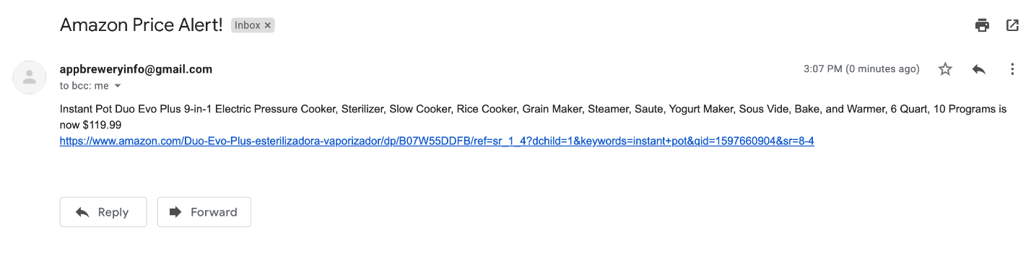

HINT: You can test the email by changing the target price to above the current live price of the product, e.g. $200.

[SOLUTION](https://gist.github.com/angelabauer/c354128af8f132ac3be461afa4480e74)

NOTE: If you have issues and keep getting this error:

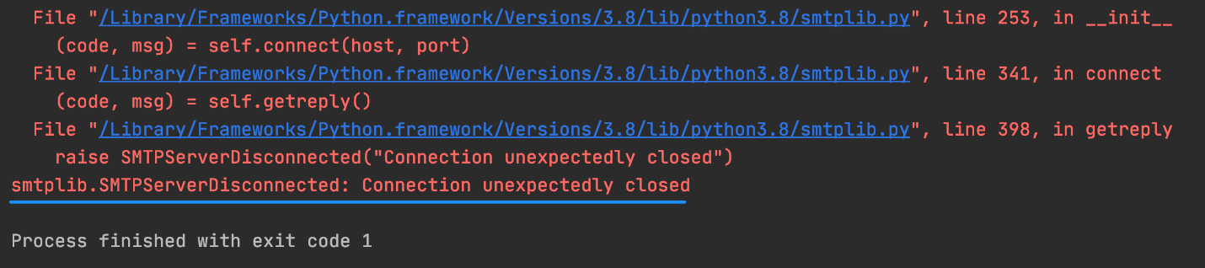

1. Make sure you've got the correct smtp address for your email provider:

Gmail: smtp.gmail.com

Hotmail: smtp.live.com

Outlook: outlook.office365.com

Yahoo: smtp.mail.yahoo.com

If you use another email provider, just Google for your email provider e.g. "Gmail SMTP address"

Below are steps specific to users sending email from Gmail addresses.

2. Make sure you've enabled less secure apps if you are sending from a Gmail account. (Refer to the video in the next lesson for steps).

3. Try to go through the Gmail Captcha here while logged in to the Gmail account: <https://accounts.google.com/DisplayUnlockCaptcha>

4. Add a port number by changing your code to this:

smtplib.SMTP("smtp.gmail.com", port=587)

Resources for this lecture